SCHOOL OF MATHEMATICS AND PHYSICAL SCIENCES
DEPARTMENT OF STATISTICS AND ACTURIAL SCIENCES


TITTLE: PREDICTIVE MODELLING OF FETAL HEALTH OUTCOMES

DECLARATION
We hereby declare that this is our original work and the ideas presented are as the result of our independent study and analysis.
SUBMITTED BY:

NAME REG.NUMBER: SAMSON JOSEPH SCM223-0103/2020
DATE………30/04/2020…………… SIGNATURE…………………………….

FELIX ONYANGO OUMA SCM223-0704/2020

DATE……30/04/2024……………… SIGNATURE…………………………….

SAOLI. M. NAISHORUA SCM223-0135/2019

DATE……30/04/2024……………… SIGNATURE…………………………….

BRIAN OMWENGA ONKOBA SCM223-0159/2020

DATE……30/04/2024……………… SIGNATURE…………………………….

STANLEY GICHARU MUGO SCM223-0621/2020

DATE………30/04/2024…………… SIGNATURE…………………………….

SUPERVISOR:

Dr. SAMUEL MUTUA

SIGNATURE: ……… ..................................Date: 30/04/2024............

Executive Summary
The study aims to revolutionize prenatal care by developing robust predictive models to assess fetal health outcomes based on Cardiotocogram (CTG) features. CTG monitoring, a widely used technique, records fetal heart rate and uterine contractions, providing insights into fetal well-being. However, current approaches may not fully exploit the wealth of information inherent in CTG data, necessitating advanced analytical methods. The primary objective is to evaluate the predictive power of CTG features in determining fetal health outcomes using machine learning models. Specifically, the study fits and compares the performance of Logistic Regression (LR) and Support Vector Machine (SVM) models, establishing best practices for predictive modeling based on CTG data. The study addresses significant gaps in the literature, including insufficiency of methodical validation and comparison of predictive models for interpreting CTG data, as well as limited insights into the meaningful connections between CTG features and specific fetal health outcomes. By investigating these relationships, the study aims to provide a clearer understanding of the patterns signaling fetal distress, ultimately contributing to improved clinical interpretability and decision-making. The methodology involves rigorous data preprocessing, including handling missing values, outlier detection, and feature extraction using Principal Component Analysis (PCA). The Logistic Regression and SVM models are then fitted using PCA components (6) and evaluated using performance metrics such as precision, recall, F1-score, and area under the receiver operating characteristic (AUC-ROC) curve. The results demonstrate that SVM model outperformed the Logistic Regression with reference to the metrics scores for precision, recall, and F1- score. The SVM model exhibit high AUC-ROC values than the Logistic Regression model, indicating its ability to discriminate between fetal health outcome classes effectively. The study contributes significantly to maternal-fetal medicine by establishing robust predictive models that can enhance the precision of detecting fetal distress and enable timely interventions, ultimately improving maternal and neonatal healthcare outcomes.
Table of Contents
DECLARATION i
Executive Summary ii
LIST OF TABLE FIGURES vi
LIST OF TABLES vi
LIST OFABREVIATIONS vi
CHAPTER ONE 1
INTRODUCTION 1
1.0 Overview 1
1.1 Background of the study 1
1.2 Statement of the problem 4
1.3 0bjectives 4
1.3.1 General Objective 4
1.3.2 Specific objectives 4
1.4 Justification 5
1.5 Data pre-processing 5
1.6 Definition of terms 6
CHAPTER TWO 8
LITERATURE REVIEW 8
2.0 Introduction 8
2.2 Study Gap 14
CHAPTER THREE 16
METHODOLOGY 16
3.0 Introduction 16
3.1 Logistic Regression 16
3.1.1 Assumptions of logistic model 16
3.1.2 More than two outcomes 16
3.1.3 Formulation of the Logistic Regression Model 17
3.2 Support Vector Machine (SVM) 17
3.2.1 Overview 17
3.2.2 Parameters in support vector machines (SVM) 17
3.2.3 Linear SVM Kernel 18
3.2.4 Non Linear SVM Kernel 18
3.3 Principle Component Analysis (PCA) 19
3.3.1 Assumptions of Principal Component Analysis(PCA) 19
3.3.2 Formulation of Principal Component Analysis(PCA) 19
3.3.3 Selecting Principal Components. 20
3.4 Model Performance 20
3.4.1 Confusion Matrix 20
3.4.2 Precision (Positive Predictive Value) 21
3.4.3 Recall (Sensitivity, True Positive Rate) 21
3.4.4 F1-Score 21
3.4.5 ROC-AUC Curve 21
3.5 Data Description 22
About the Data 22
CHAPTER 4 24
RESULTS AND DICUSSION 24
4.0 Introduction 24
4.1 Descriptive Summary Table 24
4.2 Box Plot 24
4.3 Correlation Table 25
4.4 Distribution of the Fetal Health Outcome 26
4.5 Principal Component. 26
4.5.1 Selecting Principal Components 27
4.5.1.1 Kaiser’s Criterion 27
4.5.2 PCA Model equation 29
4.5.3 PCA Visualization 30
4.6 Logistic Regression 31
4.6.1 Logistic equation 31
4.6.2 Interpretation of coefficients results 31
4.6.3 Logistic Model assumptions 32
4.6.4 Model Performance Results 32
4.6.5 Confusion Matrix 33
4.6.5 AUC-ROC Curve 34
4.7 Support Vector Machine 34
4.7.1 Model performance 35
4.7.2 Confusion Matrix 35
4.7.3 AUC-ROC Curve 36
4.7.4 Hypertunning 36
4.8 Comparison of the Models 36
CHAPTER FIVE 38
SUMMARY, CONCLUSION AND RECOMMENDATIONS 38
5.1 Introduction 38
5.2 Summary of Findings 38
5.3 Conclusions 38
5.4 Recommendations 39
5.5 Suggestions for Further Studies 39
References 40
APPENDIX 42
Data link: 42
Codes 42

LIST OF TABLE FIGURES
Figure 1:Box-plot results after removing outliers 25
Figure 2:Correlation by the Use of Heat Map 25
Figure 3:Fetal Health distribution 26
Figure 4: Scree Plot 28
Figure 5:Variance Information 29
Figure 6:Visualization of PCA 30
Figure 7:AUC-ROC Curve of Logistic Regression 33
Figure 8:AUC-ROC Curve of SVM model 35
Figure 9:Comparison of Logistic Regression and SVM using Metrics scores 36

LIST OF TABLES
Table 1:Confusion Matrix 21
Table 2:CTG-Features 22
Table 3:Descriptive Summary of four CTG features 24
Table 4: process of fitting PCA 27
Table 5: Eigenvalues 27
Table 6:Percentage of variance explained 29
Table 7: Logistic Regression Coefficients of the Fetal Health Outcome 31
Table 8:Model Performance for Logistic Regression 32
Table 9:Confusion Matrix of Logistics Regression Model 33
Table 10:Result for SVM Kernels 34
Table 11:Model Performance for SVM 35
Table 12:Confusion Matrix for SVM 35
Table 13:Comparison of the Logistics and SVM 37

LIST OFABREVIATIONS
CTG Cardiotocogram
SVM Support Vector machine
UA Uterine Activity
FHR Fetal Heart Rate
SGA Small for Gestational Edge
LGA Large for Gestational Edge
LDs Light Decelerations
SDs Severe Decelerations
PDs Prolonged Decelerations
ML Machine Learning
ADA B Ada-Boosting of Decision Tree
RF Random Forest
kNN k-nearest Neighbor
DT Decision Tree
NB Naïve Bayes
NN MLP Neural Network Multi-Layer Perceptron
LightGBM Light Gradient Boosting Machine
LR Logistic Regression
PCA Principle Component Analysis
AI Artificial Intelligenc

CHAPTER ONE

INTRODUCTION

1.0 Overview
The chapter provides background on the importance of predicting fetal health outcomes using cardiotocography (CTG) data. It outlines the research problem, objectives, justification, and a brief overview of data preprocessing. The main objective is to evaluate the predictive power of CTG features for fetal health assessment using machine learning models. The chapter highlights the need for robust predictive models to enable timely interventions and improve maternal-fetal care.

1.1 Background of the study
The prediction and modeling of fetal health outcomes through the analysis of Cardiotocogram (CTG) features represent a critical area of study with profound implications for maternal and neonatal healthcare. Cardiotocography, a widely used monitoring technique during pregnancy, records the fetal heart rate (FHR) and uterine contractions, providing essential insights into fetal well-being. Despite its routine application, there exists a compelling need to explore deeper into the predictive capabilities of CTG features to enhance our understanding of fetal health and, consequently, improve clinical outcomes. However, the recognition that current approaches to fetal monitoring may not fully exploit the wealth of information rooted in CTG data.
The realm of maternal-fetal medicine has been significantly impacted by the evolution of technology, particularly in the context of prenatal care. A pivotal component of the transformation is the exploration of Cardiotocography (CTG) as a means to predict and model fetal health outcomes. Despite its routine use, there is a compelling need to explore deeper into the predictive capabilities of CTG features to enhance our understanding of fetal health and improve clinical outcomes.
Additionally, the motivation by the recognition that current approaches to fetal monitoring may not fully exploit the wealth of information rooted in CTG data. Traditional methods, while invaluable, may lack the precision needed to identify understated patterns and associations indicative of fetal distress. The study is situated in the expansive field of maternal-fetal medicine, which is currently witnessing the transformative impact of technological advancements and data analytics on prenatal care.
Traditionally, CTG has played a crucial role in obstetric practices, offering insights into fetal well-being during pregnancy. However, recent strides in machine learning present a groundbreaking opportunity to extract more information from CTG recordings. The significance lies in the ability to uncover intricate patterns and associations within these recordings, potentially revolutionizing the early detection of fetal distress. The core motivation behind the study is rooted in the prospect of transforming how potential issues are identified, aiming to enable timely interventions and ultimately decrease adverse outcomes for both mothers and newborns.
By embracing cutting-edge approaches, there is the promise of ushering in a new era in maternal-fetal care. It involves leveraging technology to improve the well-being of both mothers and their infants through more precise and timely interventions. The study seeks to contribute to the paradigm shift by conducting an in-depth exploration of the available literature, identifying significant gaps and challenges that underscore the importance of the current research. Despite the enduring use of CTG over the decades, there exists a clear necessity for a more comprehensive understanding of the distinct CTG features that consistently associate with the well-being of the fetus. While certain studies have investigated isolated features of CTG analysis, a complete and unified perspective is notably absent. The present study endeavors to address the void by embarking on a thorough investigation encompassing a wide spectrum of CTG features. The ultimate goal is to determine reliable indicators within the CTG data that can serve as robust predictors for fetal health outcomes.
The literature review reveals that while prior studies have explored the possibilities of using machine learning to interpret CTG data, there is a noticeable gap in study that methodically validates and compares predictive models. The absence of standardized methodologies and agreement on the most efficient algorithms poses a challenge in translating these technological advancements into practical clinical applications. The study aims to bridge the gap by conducting a thorough evaluation of different machine learning models, such as the logistic regression model (LR) and Supporting Vector Machine (SVM)
The objective is to establish best practices for predictive modeling based on CTG data, addressing the need for a comprehensive understanding of the most effective approaches. By systematically assessing and comparing various models, the study aims to contribute significantly to the establishment of a reliable foundation for the integration of machine learning techniques in clinical settings. It, in turn holds the potential to enhance the application of CTG- based predictive modeling for improved patient outcomes.
Moreover, the existing pool of information frequently lacks clarity in elucidating the meaningful connections between features observed in CTG and distinct fetal health outcomes. While there is widespread recognition of CTG's vital role in pinpointing fetal distress, the exact patterns that signal various outcomes, such as fetal acidosis or hypoxia, remain undefined. The study takes on the challenge of filling the informational void by investigating the complex relationships between CTG features and a range of fetal health conditions.
By doing so, it aims to provide a comprehensive understanding that not only highlights the importance of CTG but also defines the specific indicators associated with different fetal health issues. The ultimate goal is to enhance the practicality of CTG monitoring in clinical settings, allowing healthcare professionals to more accurately interpret and respond to the intricate signals presented by CTG, thereby contributing to improved fetal health outcomes.
The proposed investigation also responds to the pressing need for personalized and risk- stratified approaches to prenatal care. Traditional models of fetal monitoring tend to adopt a one- size-fits-all approach, neglecting the inherent variability in maternal and fetal characteristics. By integrating advanced analytics into CTG interpretation, the study aims to contribute to the development of individualized risk assessment tools.
These tools would ensure that interventions are tailored to the unique needs and characteristics of each pregnancy, moving away from the one-size-fits-all approach. The integration of personalized risk assessment tools has the potential to revolutionize prenatal care, offering a more nuanced and effective approach that takes into account the individual circumstances of each expectant mother and her developing fetus.
The study explores into the complicated setting of CTG analysis, aiming to unlock its full potential in predicting and modeling fetal health outcomes. By addressing the gaps in current understanding, validating machine learning models, and exploring the complex relationships between CTG features and fetal health conditions, the study aspires to contribute significantly to the advancement of maternal-fetal medicine. The ultimate goal is to usher in a new era of prenatal care, where technology and data analytics synergize to offer personalized, precise, and timely interventions that enhance the well-being of both mothers and their infants.
The onset of abnormalities in fetal health can originate at various stages during pregnancy. According to the background of the study, Cardiotocography (CTG) serves as a vital tool for monitoring fetal well-being and providing insights into fetal distress. As such, the abnormalities unveiled through analysis of CTG recordings likely manifest during the timeframe when the examination is conducted.
CTG monitoring tends to be implemented during the third trimester and through labor and delivery. It tracks key indicators related to the fetus, including fetal heart rate, movements, and response to uterine contractions. Subtle changes in these patterns, identified via CTG, can signal underlying issues like fetal hypoxia and acidosis. Therefore, it is likely that most abnormalities highlighted by the predictive modeling are first detectable in the later stages of pregnancy from approximately week 28 onwards. However, some abnormalities may have origins earlier but remain unnoticed until CTG monitoring is performed. Overall, CTG analysis allows healthcare professionals to gain crucial visibility into fetal health during the critical late-stage pregnancy period and also provides insights into any abnormalities that may have initiated earlier. The predictive modeling then serves to better identify and interpret concerning patterns in the CTG data.

1.2 Statement of the problem
In contemporary obstetrics, ensuring optimal fetal health outcomes remains a paramount concern for both expectant parents and healthcare professionals. Despite advancements in medical technology, predicting and proactively addressing potential complications during pregnancy remains a complex challenge. Current approaches heavily rely on retrospective analyses and subjective assessments, lacking a robust and standardized predictive model that integrates multifaceted data sources.
Addressing the critical gap by developing a comprehensive predictive model for fetal health outcomes. The absence of a unified and precise tool for forecasting complications such as intrauterine growth restriction, preterm birth, and fetal distress hampers the ability to implement timely interventions. Furthermore, the complexities of maternal-fetal interactions and the dynamic nature of pregnancy necessitate a nuanced approach, considering a myriad of factors ranging from genetic predispositions to environmental influences.
The investigation into underexplored area, the study sought to enhance the accuracy of predicting fetal health risks and optimize prenatal care strategies. The study is composed to revolutionize obstetric practices by providing healthcare providers with a tailored and data-driven approach to anticipate and mitigate potential threats to fetal well-being. Therefore, the investigation holds profound implications for maternal and neonatal healthcare, contributing to a model shift towards proactive and personalized obstetric care.

1.3 0bjectives

1.3.1 General Objective
To evaluate the Predictive Power influence of Cardiotocogram (CTG) Features on Fetal Health Outcomes

1.3.2 Specific objectives
- To fit a logistic regression (LR) model to predict fetal health outcomes based on Cardiotocogram exams features.
- To fit a Support Vector Machine (SVM) model for fetal health outcomes based on Cardiotocogram exam features.
- To compare logistic regression (LR) model to Support Vector Machine model (SVM).

1.4 Justification
The study on "Predictive Modeling of Fetal Health Outcomes" is a timely and significant endeavor aimed at revolutionizing prenatal care. Focusing on the pressing need to improve maternal and fetal health, the study aims to develop predictive models that can anticipate fetal health outcomes based on diverse factors. This study addresses a gap in current understanding by leveraging advanced statistical and machine learning techniques to analyze extensive datasets. The practical implications are profound, with the potential to personalize interventions and reduce complications during childbirth. From a theoretical perspective, the study contributes to our understanding of factors influencing fetal health. The feasibility is supported by available electronic health records and ethical considerations. Socially and policy-wise, the study aligns with goals of improving maternal healthcare, and its timely integration into the healthcare landscape is emphasized, promising a positive impact on prenatal care practices and outcomes.

1.5 Data pre-processing
As a crucial step prior to model development, the Cardiotocography dataset will undergo comprehensive preprocessing to ensure data quality and integrity. First, the data will be inspected for, missing values, which can be handled by deletion or imputation methods. Outliers that could adversely influence the models will be detected via techniques like box plots and addressed by Z score. As appropriate, outliers will either be removed, capped to certain threshold values or retained with due precautions. The data balance between normal, suspect and pathological classes will be evaluated to check for class imbalance. If substantial imbalance exists, oversampling or under sampling methods may be utilized to compensate. Multicollinearity between predictors will be assessed using variance inflation factors, and highly correlated variables may be dropped. Throughout preprocessing, use of unsupervised algorithm, principle component analysis is used for feature extraction. The rigorous preprocessing will enhance data quality, noise filtering, visualization and prepare the CTG dataset for application of predictive models like logistic regression and support vector machines. The goal is to produce clean, balanced and representative data that allows the models to uncover reliable associations between CTG patterns and fetal health outcomes.

1.6 Definition of terms
Cardiotocography (CTG) is a monitoring technique used during pregnancy and labor to monitor the fetal heartbeat and uterine contractions. A "Normal" outcome typically features a normal baseline FHR, and occasional accelerations, with reassuring decelerations. A "Suspect" outcome may exhibit moderate abnormalities without severe compromise. Conversely, a "Pathological" outcome indicates severe abnormalities suggesting fetal distress, including minimal variability, persistent decelerations, and signs of hypoxia.
Support Vector Machines (SVMs) are a type of supervised machine learning algorithm used for classification and regression tasks. SVMs work by finding the optimal hyperplane that separates different classes in the feature space. In a binary classification scenario, the hyperplane aims to maximize the margin between the two classes, ensuring the greatest possible distance between the hyperplane and the closest data points from each class.
Support vectors are the data points closest to the hyperplane and play a crucial role in determining the optimal hyperplane. These data points essentially define the maximum margin between the classes and are the most difficult to classify correctly. By focusing on these critical instances, SVMs can learn the decision boundary that best separates the classes.
A confusion matrix is a table that summarizes how successfully a classification model predicts the true labels by providing counts of true positives, false positives, true negatives, and false negatives. The term "confusion" intuitively conveys the idea of a model mismatching or confusing the classes. A confusion matrix provides a comprehensive view of the model's performance, allowing for the calculation of various evaluation metrics, such as accuracy, precision, recall, and F1-score. Next is a comprehensive review of literature on predictive modeling of fetal health outcomes using CTG data.
Principal Component Analysis (PCA) is an unsupervised learning algorithm for pre-processing data in machine learning. It tackles the challenge of high-dimensional datasets by reducing the number of features while retaining the most important information for building models.
Unsupervised learning algorithm is a type of machine learning technique that uses artificial intelligence (AI) to identify patterns in the data set that are neither classified nor label. Unsupervised learning models don’t need supervision while training datasets making it ideal ML technique discovering patterns, groupings and differences in unstructured data. It allows a system to identify patterns within a data set on its own.

CHAPTER TWO

LITERATURE REVIEW

2.0 Introduction
The literature review focuses on predictive modeling of fetal health outcomes, addressing the crucial need for timely identification of risks to enhance prenatal care.
2.1 Literature Review
The study conducted by Rehman et al., (2020) explored fetal classification using Cardiotocography (CTG) datasets, emphasizing classification accuracy. The proposed algorithm, merging AlexNet with SVMs, addressed computational time concerns. The study utilized a dataset of 2126 CTG recordings, classifying into Normal, Pathological, and Suspected categories. Comparative analysis with recurrent neural networks, random forests, GoogleNet, DenseNet, NiftyNet, and AlexNet revealed superior time complexity in the SVM AlexNet hybrid model. Results revealed that, on the training data, classification models generated by XGBoost, decision tree, and random forest exhibited high precision (>96%) in predicting suspect and pathological fetal states based on CTG tracings. However, when applied to testing data, the XGBoost model demonstrated the highest precision (>92%) in predicting a pathological fetal state (Hoodbhoy et al., 2019). This finding underscores the robustness of the XGBoost technique in accurately identifying high-risk fetal conditions.
The study conducted by Rahmayanti et al., (2022), using a dataset obtained from the University of California Irvine Machine Learning Repository, consisting of 2,126 records of pregnant women in the third trimester. The dataset comprised 21 attributes related to the measurement of fetal heart rate (FHR) and uterine contractions (UC) on Cardiotocography (CTG). The variables, including baseline heart rate, baseline variability, acceleration and deceleration rates, and uterine contractions, were assessed according to the National Institute of Child Health and Human Development standards. The CTG results were classified by obstetrics experts, serving as the gold standard, and were generated using SisPorto 2.0, an automated CTG analysis program. The study found that without removing multicollinearity, the accuracy was higher, suggesting that machine learning algorithms, such as decision trees, could handle multicollinearity robustly. Rahmayanti et al., (2022), emphasized the impact of multicollinearity on reducing features and information essential for accurate predictions.
The study conducted by Mehbodniya et al., (2022) contributes to the growing literature on the application of machine learning (ML) algorithms in predicting fetal health, particularly utilizing Cardiotocographic (CTG) data. The use of ML in healthcare has gained momentum due to its potential to enhance disease diagnosis and prognosis. The research employs various ML algorithms, including support vector machine, random forest (RF), multi-layer perceptron, and K- nearest neighbors, to predict fetal health states categorized as normal, needs guarantee, and pathology. The findings suggest that RF outperforms other algorithms in terms of accuracy, precision, recall, F1-score, and support (Mehbodniya et al., (2022). Furthermore, the research incorporates regression analysis and correlation analysis to elucidate the influence of various factors measured through CTG on fetal health. The study underscores the potential of ML algorithms to contribute significantly to improving prenatal care and addressing health complications during gestation (Mehbodniya et al., 2022). The call for further research on feature engineering in CTG data indicates a pathway for future enhancements and more promising results in predicting fetal health.
Khare & Kumari, (2022), delves into the critical area of global child mortality, emphasizing the significant decline in rates to approximately 26 fatalities per 1000 live births in 2022. Aligned with multiple Sustainable Development Goals of the United Nations, this progress highlights human achievements in enhancing child survival. Focusing on the pivotal role of Cardiotocograms (CTGs), an affordable and straightforward tool widely adopted by healthcare professionals, the research employs three cutting-edge methodologies for data classification. These methodologies are pivotal in reducing both infant and maternal mortality rates (Khare & Kumari, 2022). The study compares the outcomes of these classifiers against the widely used random forest, revealing superior performance across the board, with an impressive 94.3% accuracy. According to Khare & Kumari, (2022), by the study underscores the pivotal role of machine learning in improving fetal health outcomes, especially when utilizing CTGs, and highlights the potential for further advancements in healthcare interventions.
A study by Chinnaiyan & Alex, (2021) focuses on leveraging machine learning classifiers, specifically Random Forest, Naïve Bayes, and Support Vector Machine, to enhance the analysis and early prediction of fetal abnormalities through Cardiotocography (CTG) data. Cardiotocography plays a crucial role in monitoring the health of the baby during pregnancy by assessing the baby's heartbeat and movement in the womb as stated by Chinnaiyan & Alex, (2021). The research utilizes 21 abdominal details extracted from CTG datasets obtained from the Machine Learning Repository. Machine learning models, such as Random Forest, Naïve Bayes, and Support Vector Machine, are employed to classify fetal conditions into normal, suspicious, or pathological categories. These models are crucial in providing a systematic approach to interpreting CTG data, aiding healthcare professionals in early detection and prediction of potential issues (Chinnaiyan & Alex, 2021). By investigating these machine learning algorithms, the study aims to contribute valuable insights into improving the accuracy and efficiency of fetal condition analysis, ultimately supporting timely interventions and better maternal and neonatal healthcare outcomes.
The study by Kuhle et al., (2018) addresses the critical need for accurate prediction models to identify pregnancies at risk for adverse fetal growth outcomes, focusing on small for gestational age (SGA) and large for gestational age (LGA) infants. The background highlights the existing gap in population-based risk assessment and the reliance on traditional regression methods in previous prediction models. The objective of the study was to employ both logistic regression and machine learning methods to identify predictors of fetal growth abnormalities and subsequently compare the diagnostic properties of these models in a population-based sample of infants born in Nova Scotia, Canada. The dataset for this study comprises information on 30,705 singleton infants born between 2009 and 2014, derived from the Nova Scotia Atlee Perinatal Database. The study assesses the models' performance using the area under the curve, providing a quantitative measure for comparison.
The study by Afridi et al., (2019) focuses on addressing the critical issue of fetal distress during childbirth, a major complication that can arise during delivery. The identification of fetal distress is crucial, and fetal heart rate (FHR) serves as a pivotal indicator. The widely practiced technique for recording FHR is Cardiotocography (CTG). However, improper analysis of CTG graphs can lead to serious consequences. The research employs six classification algorithms - Decision Tree (DT), K-Nearest Neighbors (KNN), Logistic Regression (LR), Support Vector Machine (SVM), Random Forest (RF), and Naïve Bayes (NB) - for the classification of CTG data. To enhance the classifiers' performance, a correlation-based feature selection technique is applied to eliminate unnecessary attributes. This study emphasizes the evaluation of classification algorithms using key metrics such as Accuracy, Precision, Recall, and F-measure. The results indicate that Naïve Bayes achieved notable performance with 83.06% accuracy, 92.20% precision, 83.10% recall, and 86.90% F-measure.
The study by Rakshit et al., (2022) delves into the critical domain of perinatal care, leveraging machine learning to enhance the assessment of fetal well-being through Cardiotocography (CTG). Recognizing the limitations of visual assessments, the research addresses the imperative need for more reliable methods in predicting high-risk fetuses. Leveraging a dataset from the UCI Machine Learning Repository, consisting of 21 features and 2112 data points, the study employs advanced machine learning models to classify fetal conditions into normal, suspect, or pathologic categories (Rakshit et al., 2022). Notably, the research explores 10-class distribution based on foetal heart rate patterns, providing a comprehensive analysis of various classifiers' performance through threefold cross-validation. Results indicate that several machine learning models exhibit satisfactory performance, with KNN and Decision Trees showcasing the highest accuracy (95.26%) in the 10-class classification (Rakshit et al., 2022). Other models, such as Boosting and Logistic Regression, also demonstrate respectable accuracy percentages (87.26% and 90.42%, respectively.
The study by Iraji, (2019) explores the integration of machine vision and soft computing approaches to enhance clinical decisions in the context of fetal wellbeing assessment using Cardiotocography (CTG) monitoring and uterine activity (UA) data. The visual assessment by pathologists is time-consuming, prompting the need for intelligent computer methods for efficient pre-labor fetal wellbeing assessment as stated by Iraji, (2019). The research employs various artificial intelligence models, including multi-layer architecture of a sub-adaptive neuro fuzzy inference system (MLA-ANFIS), neural networks (NN), deep stacked sparse auto-encoders (DSSAEs), and deep-ANFIS, applied to a CTG dataset (Iraji, 2019). The focus is on predicting fetal state classes, with experimental results indicating that the DSSAE model outperforms other techniques, achieving a high sensitivity of 99.716, specificity of 97.500, geometric mean of 98.602, and an impressive overall accuracy of 99.503. These findings underscore the potential of AI-driven approaches for accurate and timely assessment of fetal wellbeing, contributing to improved clinical decision-making in obstetrics.
The study conducted Ricciardi et al., (2020) focuses on improving the assessment of cardiotocography (CTG) in monitoring fetal health during the prenatal phase. Recognizing the subjectivity of visual evaluation, the researchers employed a custom-made software to extract 17 features from CTG signals. Utilizing machine learning algorithms like J48, Random Forests (RF), Ada-boosting of decision tree (ADA-B), Gradient Boosting, and Decorate, the study aimed to classify patients based on their delivery method (vaginal or caesarean section). The dataset, comprising 370 signals collected from 2000 to 2009 in public and private hospitals, underwent thorough analysis, including a univariate statistical examination. The results indicated that, despite only two features showing statistical significance, the machine learning models performed exceptionally well (Ricciardi et al., (2020). Random Forests (RF) emerged as the most effective algorithm, achieving high accuracy (91.1%), sensitivity (90.0%), and an impressive area under the curve receiver operating characteristic (AUC-ROC) of 96.7%. Ada-boosting (ADA-B) excelled in precision (92.6%) and specificity (93.1%) as stated by Ricciardi et al., (2020). Notably, excluding J48, all algorithms demonstrated AUCROC values exceeding 94.9%, showcasing the potential of machine learning in enhancing CTG assessments for predicting delivery outcomes.
Cardiotocography (CTG) plays a crucial role in monitoring fetal well-being during labor, aiming to detect signs of fetal compromise. However, interpreting CTG patterns poses a challenge due to substantial inter- and intra-observer variability as stated by O'Sullivan et al., (2021). To address this, the study focuses on leveraging machine learning for objective and consistent CTG assessment. The research introduces novel CTG features derived from both clinical expertise and system control theory, employing an autoregressive moving-average (ARMA) model to capture the dynamic response of fetal heart rate to contractions. These features are then integrated into a machine learning model to evaluate their effectiveness in identifying fetal compromise. The study by O'Sullivan et al., (2021) utilizes a dataset that likely comprises CTG recordings, although the source is not explicitly mentioned. The ARMA features emerge as prominent contributors, ranking among the top features for detecting fetal compromise. Furthermore, the study enhances the machine learning model's performance by incorporating clinical factors and implementing data pruning based on a signal quality measure.
Cardiotocography (CTG) has long been a crucial tool for monitoring fetal well-being during both antepartum and intrapartum periods, yet its application has been met with significant debate. The International Federation of Obstetrics and Gynecology (FIGO) introduced pioneering guidelines for universally classifying CTG signals, marking a pivotal step in standardizing its interpretation. Within the context of labor, variations in CTG patterns serve as vital indicators for assessing fetal conditions. In this study by Sontakke et al., (2019), the focus lies on leveraging CTG signal parameters to classify fetuses into distinct states—normal, suspect, and pathological— while also delineating 10 morphological patterns. This research contributes to the ongoing discourse surrounding the effective utilization of CTG in obstetric care and seeks to refine the understanding of fetal well-being through advanced signal analysis. The study by Sontakke et al., (2019) employs a sophisticated model to decipher CTG signals and classify fetal states, shedding light on the nuances within these categories.
The study by Chidambaram & Joy (2022) focuses on improving the early detection of fetal distress during labor and delivery, a critical aspect in reducing stillbirths. Cardiotocography (CTG) is employed as a technique to continuously monitor fetal heart rate and uterine contractions. The researchers utilize the cardiotocography dataset sourced from the UCI Machine Learning Repository to conduct a comparative analysis of various classifiers and ensemble learning methods. The objective is to enhance the prediction of fetal state, with a particular emphasis on detecting abnormalities (Chidambaram & Joy 2022). The study underscores the significance of early detection in preventing stillbirths and highlights CTG as a valuable tool for this purpose. This study employs ensemble learning methods such as max voting, weighted average, blending, bagging, and boosting, comparing their efficacy in predicting fetal states as stated by Chidambaram & Joy (2022). Among the methods evaluated, the Light Gradient Boosting Machine (LightGBM) emerges as the most successful, achieving an impressive accuracy of 95.90%. The accuracy surpasses existing models, suggesting that LightGBM could be a crucial tool for improving the precision of fetal abnormality detection.
Ravikumar & Kannan, (2022) focuses on the application of machine learning techniques in analyzing Cardiotocography (CTG) signals for assessing fetal condition. The use of computerized fetal monitoring systems is essential for providing a quantitative description of CTG signals, aiming to enhance decision support methods for determining fetal risks such as premature birth. The study employs machine learning models, including Naïve Bayes, support vector machine (SVM), decision trees, and random forest, to classify fetal heart rate signals. These models leverage advancements in obstetric practice, demonstrating the potential for reliable and robust analysis of CTG signals. The study by Ravikumar & Kannan, (2022) evaluates the proposed method using various metrics such as precision, accuracy, F1 score, recall, sensitivity, logarithmic loss, and mean absolute error, providing a comprehensive assessment of its effectiveness in predicting fetal risk. The study emphasizes the significance of low birth weight as a crucial indicator of abnormal fetal outcomes. The findings suggest that the proposed machine learning- based approach can contribute valuable insights into the fetal state after birth, providing a continuous decision support system. Additionally, the study does not provide a thorough comparison and validation of different predictive models for interpreting CTG data, leaving a gap in establishing best practices for predictive modeling based on CTG data.
The study by Alam et al., (2022), focuses on the application of machine learning (ML) in the field of obstetrics, specifically in the context of fetal health classification using Cardiotocography (CTG) data. The traditional analysis of CTG data by obstetricians is time- consuming and unreliable, prompting the need for an efficient and accurate fetal health classification model. The research explores various ML models, including random forest (RF), logistic regression, decision tree (DT), support vector classifier, voting classifier, and K-nearest neighbor (Alam et al., 2022), The investigation utilizes an open-access Cardiotocography dataset, despite its modest size, containing significant values for analysis. Among the models evaluated, the random forest model emerges as the most effective, achieving a remarkable 97.51% accuracy. The outcome suggests the potential of ML, particularly the random forest algorithm, in enhancing the accuracy and efficiency of fetal health classification (Alam et al., 2022). The study contributes valuable insights into the application of advanced ML techniques in obstetrics, paving the way for improved prenatal care through more effective and timely diagnosis. However, the study does not delve into the meaningful connections between specific CTG features and fetal health outcomes. There is little clarity in explaining the exact patterns in CTG signals that indicate conditions like fetal acidosis or hypoxia.
In the realm of maternal and fetal healthcare, Cardiotocograms (CTGs) play a pivotal role in evaluating fetal well-being and preventing adverse outcomes. The recent study by Dixit, (2022), employs machine learning (ML) techniques to predict fetal health based on features extracted from CTG exams. The dataset, comprising 2126 records categorized by expert obstetricians into Normal, Suspect, and Pathological classes, served as the foundation for the investigation. Dixit, (2022), evaluated various ML algorithms, including Logistic Regression, k-Nearest Neighbors (kNN), Support Vector Machines (SVM), Decision Tree, Extra Trees, Random Forest, Gradient Boosting, and Neural Network Multi-Layer Perceptron (NN MLP). Notably, the Random Forest model emerged as the most promising, achieving remarkable accuracy (95.77%), recall (95.77%), precision (95.87%), F1-score (95.81%), and MCC score (88.58%). Additionally, Extra Trees, Gradient Boosting, and NN MLP demonstrated robust performance. Key contributors to the prediction of fetal well-being were identified, encompassing factors such as the rate of accelerations, abnormal short-term and long-term variability of fetal heart rate, and characteristics of the histogram constructed from fetal heart rate values (width, mean, and variance) (Dixit, 2022). The study also underscored the significance of assessing the trend or histogram tendency over time as a crucial predictor, capturing dynamic changes associated with potential complications. While the study explored machine learning for predicting fetal health from CTG data, there remains a gap in comprehensively evaluating and comparing the performance of different algorithms like logistic regression and support vector machines, as well as investigating dimensionality reduction techniques like PCA. Furthermore, insufficient unified understanding of the distinct CTG features consistently associated with fetal well-being, and little insight into the meaningful connections between CTG patterns and specific fetal health outcomes like acidosis or hypoxia, highlights critical areas that require further investigation.

2.2 Study Gap
Despite the widespread utilization of Cardiotocograms (CTGs) in assessing fetal well-being, the existing literature reveals several critical gaps that warrant further investigation. While CTGs have been employed for an extended period, there is a notable little insight comprehensive understanding of the distinct features consistently associated with favorable fetal health outcomes. Most previous studies have focused on isolated features, leaving a void in achieving a unified perspective on the CTG indicators that can reliably predict fetal health. The study aims to address the gap by conducting a meticulous examination encompassing a broad spectrum of CTG features, seeking to identify robust indicators that can serve as reliable predictors of fetal well-being.
Furthermore, the literature highlights a significant gap in the methodical validation and comparison of predictive models for interpreting CTG data. Although machine learning techniques have been explored in prior studies, the absence of standardized methodologies and a consensus on the most efficient algorithms hinders practical clinical applications. The study intends to bridge the gap by conducting a thorough evaluation of different machine learning models, including logistic regression and support vector machines, aiming to establish best practices for predictive modeling based on CTG data. Additionally, the potential benefits of dimensionality reduction techniques like principal component analysis (PCA) will be investigated to enhance model interpretability and performance.
Moreover, the existing literature offers limited insights into the meaningful connections between CTG features and specific fetal health outcomes. Despite the well-recognized role of CTGs in identifying fetal distress, the exact patterns signaling adverse outcomes such as fetal acidosis or hypoxia remain undefined. The study seeks to contribute by investigating the complex relationships between CTG features and a range of fetal health conditions, aiming to provide a clearer understanding of the connections that currently contains little definition in the literature.

CHAPTER THREE

METHODOLOGY

3.0 Introduction
The methodology section of the study focuses on outlining the approach, design, and methods employed to achieve the objectives.

3.1 Logistic Regression
Logistic regression is a statistical method used for predicting the probability of an event occurring based on one or more predictor variables. Logistic Regression can be classified into three types:
- Binomial: In binomial Logistic regression, there can be only two possible types of the dependent variables.
- Multinomial: In multinomial Logistic regression, there can be 3 or more possible unordered types of the dependent variable.
- Ordinal: In ordinal Logistic regression, there can be 3 or more possible ordered types of dependent variables, such as “low”, “Medium”, or “High”.

3.1.1 Assumptions of logistic model
- Binary outcome variable- it can take only two values. For more than two categories SoftMax functions are used.
- Independence of observations- there is no correlation between any input variables.
- Linear relationship between predictors and logit of outcome- The relationship between the independent variables and the log odds of the dependent variable should be linear
- Large sample size- The sample size is sufficiently large
- No significant outliers- There should be no outliers in the dataset.

3.1.2 More than two outcomes
The event of interest is the fetal health outcome, which can be categorized as normal (1), suspect (2) and pathological (3). Multinomial Logistic regression is particularly suited for such multiclass outcomes.

3.1.2.1 Softmax Function
Multivariate Logistic regression uses the Softmax function to model the relationship between the independent variables and the probability of the multiclass outcome.
(3.1)
$$Softmax\left(zi\right)= \frac{e^{zi}}{\sum_{j=1}^{k}{e^{zj}}}$$
Here, K represents the number of elements in the vector z, and i, j iterates over all the elements in the vector.
Then the probability for class c will be:
(3.2)
$$P(Y=c|\overset{→}{X}=x)=\frac{e^{{w_{c}}^{.x}+b_{c}}}{\sum_{k=1}^{K}{e^{w_{k^{.x}+b_{k}}}}}$$

3.1.3 Formulation of the Logistic Regression Model
In logistic regression, the log-odds (also known as logit) of the outcome is modelled as a linear combination of the independent variables. The log-odds reflect the natural logarithm of the odds ratio, which quantifies the likelihood of the outcome occurring relative to not occurring
The linear combination is denoted as:
(3.3)
$$logit\left(p\right)=β_{0}+β_{1}X_{1}+β_{2}X_{2}…+β_{n}X_{n}$$
Where:
Logit (p) represents the log-odds of the outcome. P denotes the probability of the outcome.
βo, β1, β2... βn are the regression coefficients associated with the independent variables. X1, X2... Xn represent the values of the independent variables.

3.2 Support Vector Machine (SVM)

3.2.1 Overview
Support Vector Machine is a supervised learning algorithm that analyzes data for classification and regression analysis. In the context of fetal health outcomes, SVM can be applied to predict whether a given set of CTG features corresponds to a healthy or compromised fetal state.

3.2.2 Parameters in support vector machines (SVM)

3.2.2.1 Cost Function (Regularization Parameter)
It controls the trade-off between maximizing the margin and minimizing misclassification error. A large C value emphasizes more on reducing misclassification while a small C focuses more on maximizing the margin.

3.2.2.2 Gamma (Kernel Parameter)
It defines how much influence a single training example can have.
Gamma works together with the kernel function (linear, polynomial, radial basis etc). It is used in non-linear SVMs to control the flexibility or curvature of the decision boundary.
The optimal values of C and Gamma are found using a grid search procedure and cross-validation to evaluate model performance across the hyper parameter space. The goal is to tune these two parameters to optimize the complexity and generalization ability of the SVM model for the given dataset.

3.2.3 Linear SVM Kernel
Linear SVM (Support Vector Machine) aims to find a hyperplane that best separates the data into classes. The mathematical formula for a linear SVM is based on the equation of a hyperplane:
(3.4)
$$F\left(X\right)=W.x+b$$

Where:
f(x) is the decision function. w is the weight vector.
x is the input vector.
b is the bias term.
The objective is to maximize the margin between classes, represented by the distance between the hyperplane and the nearest data points, called support vectors.

3.2.4 Non Linear SVM Kernel
Nonlinear SVM introduces the concept of kernels to handle cases where the data is not linearly separable. Common kernels include Polynomial Kernel, Radial Basis Function (RBF) Kernel and Sigmoid Kernel.

3.2.4.1 Polynomial Kernel
It is popular in image processing
Its equation is:
(3.5)
$$K\left(x,y\right)=(k.y+1)d$$

Where d is the degree of the polynomial

3.2.4.2 Gaussian Radial Basis Function (RBF) Kernel
It is a general –purpose kernel; used when there is no prior knowledge about the data.
The equation is;
(3.6)
$$K\left(x,y\right)=exp\left(-y{\left|\left|x-y\right|\right|}^{2}\right)$$
For y>0

3.2.4.3 Sigmoid Kernel
It can be used as the proxy for a neural network.
Its equation is:
(3.7)
$$K\left(x,y\right)=\tan{h\left(ax.y+c\right)}$$

The decision function in the case of nonlinear SVM becomes:
(3.8)

$$f\left(x\right)=\sum{N}αi yiK\left(y,x\right)+b$$
𝑖=1, 2, …, n
Where:
F(x) is the predicted class for input x.
αi are the Lagrange multipliers.
yi is the class label of the i^{th} training example.
K (y, x) is the kernel function, responsible for transforming the input features. b is the biased term
The kernel functions effectively map the input data into higher-dimensional spaces, making it possible to find a hyperplane that separates the classes.

3.3 Principle Component Analysis (PCA)
The algorithm can be used on its own or it can serve as a data cleaning or data preprocessing technique used before another machine learning algorithm.

3.3.1 Assumptions of Principal Component Analysis(PCA)
- PCA assumes a correlation between features
- PCA is sensitive to the scale of the Features
- PCA is not robust against outliers
- PCA assumes a linear relationship between Features
- Technical Implementations often assumes no missing values

3.3.2 Formulation of Principal Component Analysis(PCA)
Given a dataset with n observations and p variables represented by the n x p data matrix X, the goal of PCA is to transform the original variables into a new set of k variables called principal components that capture the most significant variation in the data. The principal components are defined as linear combinations of the original variables given by:
$$PC_{1}=a_{11}*X_{1}+a_{12}*X_{2}…+a_{1P}*X_{p}$$
(3.9)
$$PC_{2}=a_{21}*X_{1}+a_{22}*X_{2}…+a_{2P}*X_{p}$$
…
$$PC_{k}=a_{k1}*X_{1}+a_{k2}*X_{2}…+a_{kP}*X_{p}$$
where a_ij is the eigenvector or weight of variable x_j on principal component PC_i, and x_j is the j^{th} variable in the data matrix X. The principal components are ordered such that the first component PC_1 captures the most significant variation in the data, the second component PC_2 captures the second most significant variation, and so on. The number of principal components used in the analysis, k, determines the reduced dimensionality of the dataset.

3.3.3 Selecting Principal Components.
There are three ways used when selecting the number of principle components to be retained.
- Scree Plot
Scree plot is used to identify principal components that upper first below the ‘elbow’ (Sharp) change of the curve to use in analysis.
- Kaiser’s criterion plot
It is used in standardized data where you take the principal components in whose Eigen value >1 to use in analysis.
- Variance information
It chooses number of components that explain satisfactory amount of variance e.g. 80-90.

3.4 Model Performance

3.4.1 Confusion Matrix
The confusion matrix allows to visualize the cases where a classification model gets confused between the actual and predicted classes.
To calculate the confusion matrix based on the model predictions and actual outcomes. The confusion matrix includes four metrics: True Positive (TP), True Negative (TN), False Positive (FP), and False Negative (FN).

Table 1:Confusion Matrix
 | Predicted Positive | Predicted Negative
Actual Positive | True Positive (TP) | False Negative (FN)
Actual Negative | False Positive (FP) | True Negative (TN)

3.4.2 Precision (Positive Predictive Value)
Precision is the ratio of correctly predicted positive observations to the total predicted positives. It measures the accuracy of the positive predictions.
(3.9)
$$Precision=\frac{TP}{TP+FP}$$

3.4.3 Recall (Sensitivity, True Positive Rate)
Recall is the ratio of correctly predicted positive observations to the all observations in the actual positive class. It measures the model's ability to capture all the relevant instances.
(3.10)
$$Recall=\frac{TP}{TP+FN}$$

3.4.4 F1-Score
The F1 score is the harmonic mean of precision and recall. It provides a balance between precision and recall.
(3.11)
$$F1 Score=2*\frac{Precision*Recall}{Precision+Recall}$$

3.4.5 ROC-AUC Curve
The genuine positive rate is plotted against the false positive rate in a graphical format using the Receiver Operating Characteristic (ROC) curve and Area Under the Curve (AUC). AUC or ROC Curve measures a classification model's overall effectiveness.

3.5 Data Description

About the Data
The dataset comprises features extracted from Cardiotocogram exams. These features are derived from the analysis of fetal health indicators, including fetal heart rate (FHR), fetal movements, uterine contractions, and more. The data is a compilation of 1489 records, each labeled based on the classification provided by expert obstetricians.
Table 2:CTG-Features
Variables | Description
baseline_value | Baseline Fetal Heart Rate  (FHR) (beats per minute)
Accelerations | Number of accelerations per  second
fetal_movement | uterine_contractions
light_decelerations | Number of light decelerations (LDs) per second
severe_decelerations | Number of severe decelerations (SDs) per second
prolongued_decelerat ions | Number of prolonged decelerations (PDs) per second
abnormal_short_term  _variability | Percentage of time with abnormal short-term variability
mean_value_of_short  _term_variability | Mean value of short-term variability
percentage_of_time_ with_abnormal_long_ ter m_variability | Percentage of time with abnormal long-term variability
mean_value_of_long  _term_variability | Mean value of long-term variability
histogram_width | Width of histogram made using all values from a record

histogram_min | Histogram minimum value
histogram_max | Histogram
histogram_number_of  _peaks | Number of peaks in the exam  histogram
histogram_number_of  _zeroes | Number of zeros in the exam histogram
histogram_mode | Histogram mode
histogram_mean | Histogram mean
histogram_median | histogram_median
histogram_variance | histogram_variance
histogram_tendency | histogram_tendency
fetal_health | Encoded as 1-Normal; 2-  Suspect; 3-Pathological.

CHAPTER 4

RESULTS AND DICUSSION

4.0 Introduction
The chapter presents the findings of the data analysis and their interpretation. It entails a brief overview of the study objectives, goals and importance of predicting fetal health outcomes using machine learning models. The study aims to evaluate CTG features as robust predictors and establish best practices for predictive modeling, contributing significantly to maternal-fetal medicine through enhanced precision in detecting fetal distress. Python is the software that has been mainly utilized to obtain the results.

4.1 Descriptive Summary Table
Table 3, shows the summary statistics of some main CTG features that have been included in the model. These include the mean, median, standard deviation, Min and Max.
Table 3:Descriptive Summary of four CTG features
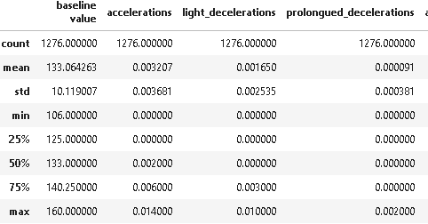

4.2 Box Plot
Figure 1, demonstrated the box plot of CTG features that was capped to between 25% and 75% of the actual mean after application of Z score due to presence of outliers.

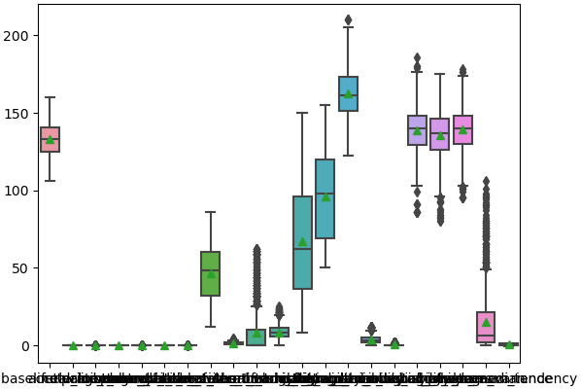
Figure 1:Box-plot results after removing outliers

4.3 Correlation Table
Figure 2, Heat Map plot for correlation of the CTG features, scale Red (positive), signifies high correlation, and Blue (negative) signifies relatively low correlation.
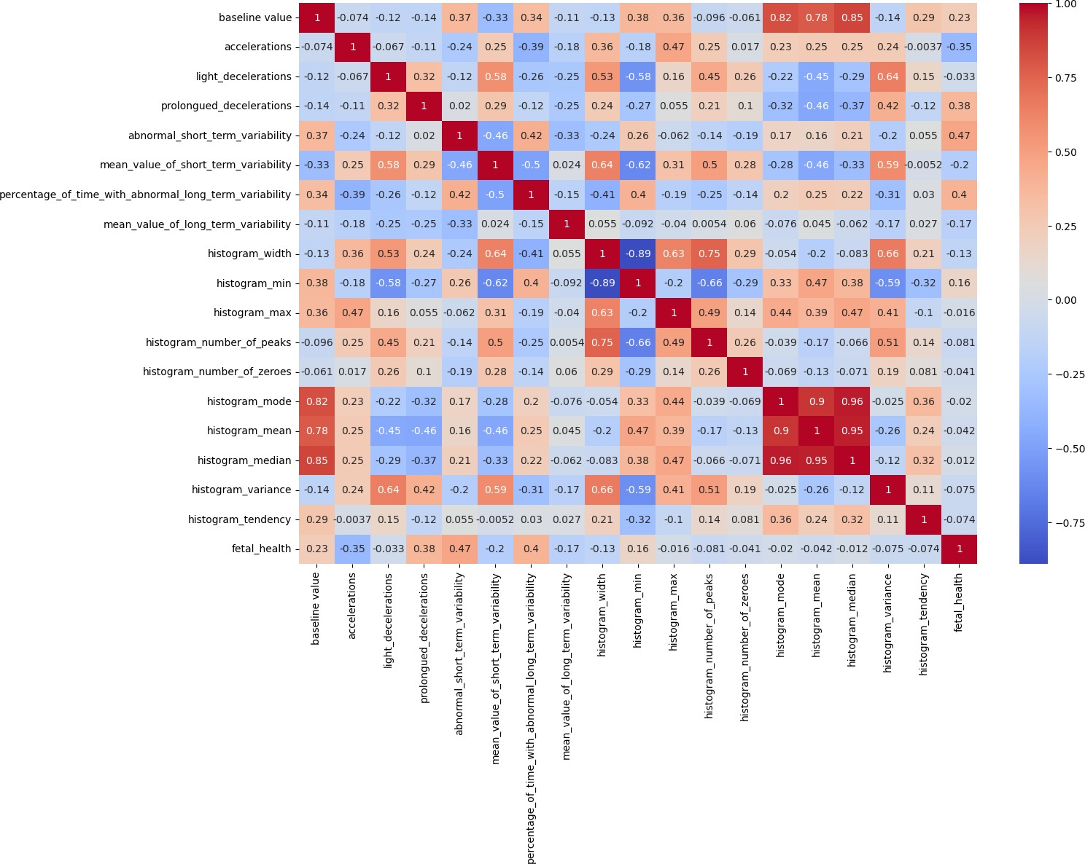
Figure 2: Correlation by the Use of Heat Map

Figure 2, Demonstrated that the most CTG features and the fetal health outcomes are lowly correlated since their presence already increases the high probability to normal fetal health outcome examples from the figure 2, accelerations, light-deceleration, histogram_width while some must correlate highly with fetal health outcomes to decreases cases of suspect and pathological fetal health outcomes examples from the figure x, abnormal_short_term_variability, histogram_min.

4.4 Distribution of the Fetal Health Outcome
Figure 3, the majority class was class 1 (Normal) and both class 2 (Suspect) & 3 (Pathological) forms the minority class and indacated that the dataset was Imbalanced.

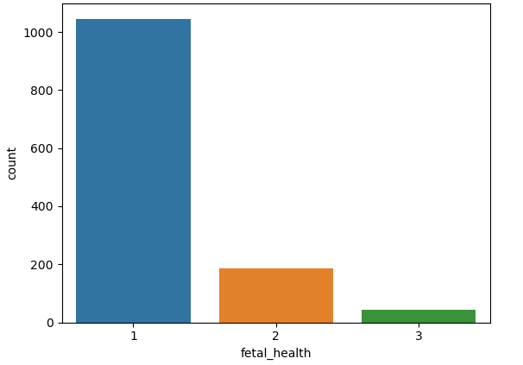
Figure 3:Fetal Health distribution

4.5 Principal Component.
Table 4, Demonstrated the CTG features standardization, for Principal Component analysis to be carried the CTG-features values were standardized first for both the mean and variance values and then fit the PCA.

Table 4: process of fitting PCA
Baseline value | 6.327077e-16 | 1.0
Accelerations | -9.430927e-17 | 1.0
Light Deceleration | 7.162729e-18 | 1.0
Prolonged Deceleration | -7.640244e-17 | 1.0
Abnormal Short term Variability | 5.730183e-17 | 1.0
Mean value of Short term Variability | 5.968941e-18 | 1.0
Percentage of time with abnormal long term Variability | 5.968941e-18 | 1.0
Mean value of long term Variability | -6.267388e-17 | 1.0
Histogram Width | 1.456422e-16 | 1.0
Histogram Min | -4.297638e-17 | 1.0
Histogram Max | -5.360109e-16 | 1.0
Histogram number of peaks | -1.360919e-16 | 1.0
Histogram number of zeroes | 9.550306e-18 | 1.0
Histogram mode | -3.557489e-16 | 1.0
Histogram mean | 3.891750e-16 | 1.0
Histogram median | 2.304011e-16 | 1.0
Histogram Variance | 0.000000e+00 | 1.0
Histogram Tendency | 8.834033e-17 | 1.0

4.5.1 Selecting Principal Components

4.5.1.1 Kaiser’s Criterion
Table 5: Eigenvalues
Eigenvalues | values
1 | 5.7446
2 | 3.8507
3 | 1.8765
4 | 1.4075
5 | 0.98631
… | …
17 | 1.05e-31

Table 5, Kaiser’s criterion method selects principal components whose eigenvalues are greater than one, it was clearly evident that the four eigenvalues are greater than one and was concluded that only four Principal Component was selected.

4.5.1.2 Scree plot
Figure 4, demonstrated that the most obvious change in slope in the scree plot occurred at component 5, which was the ‘elbow’ of the scree plot. Therefore, it could be argued on the basis of the scree plot that the first four principal components was selected(visualization of the kaiser’s criterion method).

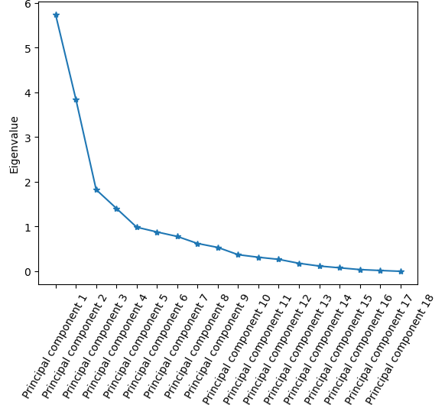
Figure 4: Scree Plot

4.5.1.3 Variance information
Figure 5, Demonstrated that the number of principal component that explained 80% of variance information was found to be six and thus concluded that six principal component was selected. 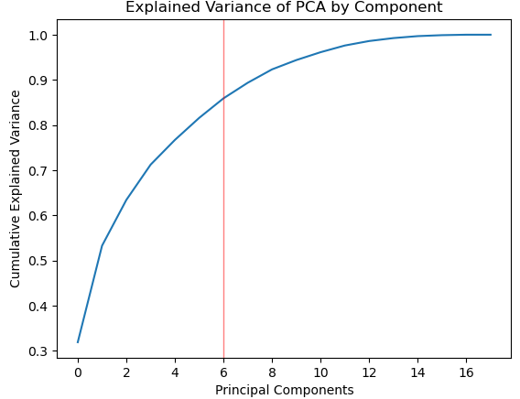
Figure 5:Variance Information

4.5.1.4 Percentage of variance explained
Table 6:Percentage of variance explained
Explained Variance Ratio
Principal component 1 | 0.318894
Principal component 2 | 0.213733
Principal component 3 | 0.101407
Principal component 4 | 0.078132
Principal component 5 | 0.054751
Principal component 6 | 0.048828
Total | 0.815745

4.5.2 PCA Model equation
By the use of Variance information method of selecting principal Components, six principal components was selected because they explained much of variance information i.e they explained 80% of the variance information obtained across the CTG-datasets
principal components are ordered by the amount of variance they capture from the original dataset. PC1 captures the most variance, followed by PC2, PC3, PC4,PC5 AND lastly PC6.
The following is the equation of the six pricncipal componnents which is a linear combination of eigen vectors and CTG-features.

Equation 1:PCA of CTG features
$$PC_{1}=-0.2559*X_{1}+0.7123*X_{2}+…+0.01402*X_{17}$$
$$PC_{2}= 0.3091*X_{1}+0.2561*X_{2}+…+0.19653*X_{17}$$
$$PC_{3}= 0.2158*X_{1}– 0.3114X2*X_{2}+…++ 0.1328*X_{17}$$
…
$$PC_{6}= -0.0844*X_{1}– 0.04754*X_{2}+…- 0.1057*X_{17}$$

From the selecting Principal Component method that were discussed there was evidence that applying Principal Component Analysis to the Cadiocogram exams features it was able to not only reduced dimensionality from 22 to 6 but also De-noise the data by finding the Principal Components which explains the greatest amount of variance.

4.5.3 PCA Visualization
Figure 6,Demonstrated how after the Principal Components Analysis(PCA) was able to classify the three fetal health outcomes i.e class 1= “Normal”, class 2=”Suspect” and lastly class 3 = “Pathological”.
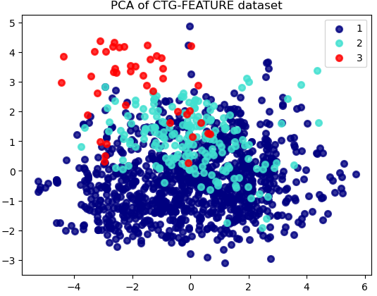
Figure 6:Visualization of PCA

4.6 Logistic Regression

4.6.1 Logistic equation
Logistic Regression equation was obtained and expressed also as linear combination of the beta’s coefficients and the six Principal Components chosen from the method of selecting principal components$$logit\left(1\right)=3.8398+0.01408{PC}_{1}-0.01797{PC}_{2}-0.10764{PC}_{3}+…+0.00853{PC}_{6}$$
$$logit\left(2\right)=0.9300-0.01082{PC}_{1}-0.02442{PC}_{2}-0.02857{PC}_{3}+…+0.02067{PC}_{6}$$
$$logit\left(3\right)=-4.477-0.00343{PC}_{1}-0.00644{PC}_{2}+0.02857{PC}_{3}+…-0.02905{PC}_{6}$$

4.6.2 Interpretation of coefficients results

Table 7: Logistic Regression Coefficients of the Fetal Health Outcome
Principal Component | Normal | Suspect | Pathological
Intercept | 3.83981 | 0.93000 | -4.47698
Principal Component 1 | 0.01426 | -0.01082 | -0.00343
Principal Component 2 | -0.01797 | -0.02442 | -0.00644
Principal Component 3 | -0.10764 | -0.02857 | 0.13621
Principal Component 4 | -0.00953 | -0.03535 | 0.04489
Principal Component 5 | -0.04449 | -0.03966 | 0.08416
Principal Component 6 | 0.00838 | 0.02067 | -0.02905

Table 7: Demonstrated in terms of intercept was followed that
- When all principal components are kept constant there was an increase of 3.8398 unit probability chances that the fetal health outcome was class 1(Normal).
- When all principal components are kept constant there was an increase of 0.93 unit probability chances that the fetal health outcome was class 2(Suspect).
- When all principal components are kept constant there was a decrease of -4.7698 unit probability chances that the fetal health outcome was class 3(Pathological).
Table 7, also indicated that only the second Principal component relate with all three classes negatively while Principal components 3, 4, 5, and 6 was relating with each other as follow, if both class 1 and class 2 relate positively then class 3 relates negatively and again was noted also if both class 1 and class 2 relate negatively then class 3 relates positively.

4.6.3 Logistic Model assumptions
All the assumptions of the logistic regression model were met.

4.6.4 Model Performance Results

Table 8:Model Performance for Logistic Regression
Metric score
Precision(1 89%
Precision(2 44%
Precision(3 15%
Recall(1) 95%
Recall(2) 21%
Recall(3) 22%
Fi-Score(1) 92%
Fi-Score(2) 28%
Fi-Score(4) 18%

Table 8, the precision score of 0.89 for class 1 was above 0.5 indicated that the logistic Regression model was a good model to positive prediction while the model struggles to do so for both class 2 and class 3. Recall score of 0.95 for class 1 had a value above 0.5 indicted that logistic regression model ability to capture all the relevant instances correctly in the CTG-features dataset while it struggles in both classes 2 and class 3 whose score of 0.21 and 0.22 respectively were below 0.5. An F1 score of 0.92 suggests that the logistic Regression model has achieved a good balance between precision and recall in predicting the class 1 while for both class 2 and class 3 logistic regression models struggles to predict their classes since their values are less than 0.5.

4.6.5 Confusion Matrix
Table 9:Confusion Matrix of Logistics Regression Model
 |  |  | predicted
 |  | class 1 | class 2 | class 3
 | class 1 | 203 | 9 | 1
Actual | class 2 | 17 | 7 | 10
 | class 3 | 7 | 0 | 2

Table 9 ,indicated that the model had a good understanding of class 1 but faces challenges in accurately classifying instances belonging to classes 2 and 3.

- True positive(TP)- 203
- False positive(FP)- 17 & 7
- True Negative(TN)-7 , 10, 0 & 2
- False Negative(FN)-9 & 1

4.6.5 AUC-ROC Curve
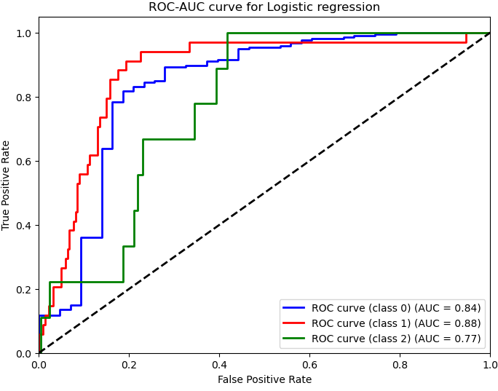
Figure 7:AUC-ROC Curve of Logistic Regression
Figure 7, showed a high promising results outcomes with scores of 84%, 88% and 77% of each class respectively, meaning the logistics model can be used to predict the fetal health outcomes.

4.7 Support Vector Machine
The SVM model uses the linear and non-linear SVM kernel to classify the three classes of the fetal health outcomes .Their accuracy was obtained as follows
Table 10:Result for SVM Kernels
Kernel | Accuracy
Linear | 85.47%
Radial | 87.50%
sigmoid | 73.04%
Polynomial | 87.10%

Table 10, indicated that the non-linear SVM kernels particularly the Gaussian Radial basis function outperformed the linear kernel with an accuracy of 87.5% and concluded that it was the best in classifying the three classes separately. Therefore, non-linear SVM i.e. the Gaussian Radial basis function was a good model fit to predict fetal health outcomes using the CTG features

4.7.1 Model performance
Table 11:Model Performance for SVM
Metric | Score
Precision(1) | 88%
Precision(2) | 76%
Precision(3) | 100%
Recall(1) | 98%
Recall(2) | 38%
Recall(3) | 11%
Fi-Score(1) | 93%
Fi-Score(2) | 51%
Fi-Score(4) | 20%

Table 11, Precision scores of 0.88, 0.76 and 1.00 for all the three classes was above 0.5 indicated that SVM was a good model that predicts a positive. A recall score of 0.98 of class 1 was greater than 0.5 indicted that SVM model ability to capture all the relevant instances correctly in the CTG-features dataset while it struggles in both class 2 and class 3 whose score of 0.38 and 0.11 were below 0.5. F1 scores of 0.93 and 0.51 suggests that SVM model has achieved a good balance between precision and recall in predicting both class 1 and class 2 while class 3 SVM model struggles to predict it since a score of 0.20 was less than 0.5.

4.7.2 Confusion Matrix
Table 12:Confusion Matrix for SVM
 |  |  | predicted
 |  | class 1 | class 2 | class 3
 | class 1 | 209 | 4 | 0
Actual | class 2 | 21 | 13 | 0
 | class 3 | 8 | 0 | 1

Table 12, indicates that the model has a good understanding of class 1 but faces challenges in accurately classifying instances belonging to classes 2 and 3.
- True positive(TP)- 209
- False positive(FP)- 21 & 8
- True Negative(TN)-13 , 0, 0 & 1
- False Negative(FN)-4 & 1

4.7.3 AUC-ROC Curve
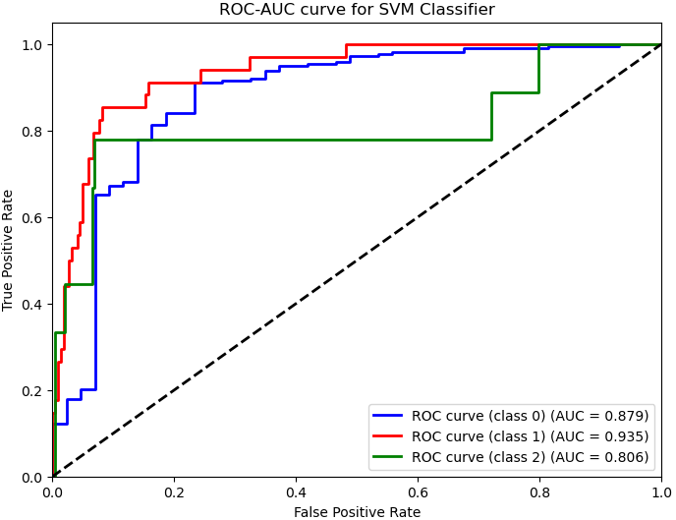
Figure 8:AUC-ROC Curve of SVM model
Figure 8, shows high promising results outcomes of 88%, 94% and 81% of each class respectively, meaning the logistics model can be used to predict the fetal health outcomes

4.7.4 Hypertunning
The cost parameter was set in the interval of 0.1 to 10 by the use of Gridserach where cross validation was carried out upon the SVM kernels the Polynomial which is non-linear SVM kernel outperformed the others SVM kernels

4.8 Comparison of the Models
The study used Metric Score to compare the performance of the two models.

Table 13:Comparison of the Logistics and SVM
Metric | logistic regression | SVM
Precision(1) | 89% | 88%
Precision(2) | 44% | 76%
Precision(3) | 15% | 100%
Recall(1) | 95% | 98%
Recall(2) | 21% | 38%
Recall(3) | 22% | 11%
Fi-Score(1) | 92% | 93%
Fi-Score(2) | 28% | 51%
Fi-Score(4) | 18% | 20%

Figure 9, it was clearly indication that the SVM model outperformed the Logistics Regression model in most of the model performance metrics scores thus was concluded that SVM model was better in predicting correctly the Fetal health Outcomes given the exams of Cadiocotogram features.

Figure 9:Comparison of Logistic Regression and SVM using Metrics scores

CHAPTER FIVE

SUMMARY, CONCLUSION AND RECOMMENDATIONS

5.1 Introduction
The chapter focuses on the summary of findings, conclusions of the study, recommendations, and suggestions for further studies based on the analysis of Cardiotocogram (CTG) features in predicting fetal health outcomes using machine learning models.

5.2 Summary of Findings
The descriptive summary table provided an overview of the key CTG features included in the model, highlighting their central tendencies and dispersion. The correlation analysis revealed low correlation among the CTG features, indicating their independence. The distribution of fetal health outcomes was imbalanced, with the majority class belonging to Class 1 (Normal), while Classes 2 (Suspect) and 3 (Pathological) formed the minority classes. Principal component analysis (PCA) was performed to reduce the dimensionality of the data, and the optimal number of principal components was determined using the variance information.
Both SVM and Logistic regression model demonstrated promising performance with accuracy scores of 87.5% and 82.8%. The precision score of 89%, recall score of 95%, and F1-score of 92% for class 1 were above 50% demonstrated both are good models tp predict class 1 but struggled to predict both class 2 and class 3 since most of their values are below 50%.Both models exhibited high area under the receiver operating characteristic (AUROC) curve values, suggesting their ability to discriminate between the fetal health outcome classes effectively.

5.3 Conclusions
The study demonstrated the potential of CTG features in predicting fetal health outcomes using machine learning models. Both the logistic regression and SVM models achieved comparable performance, with the SVM model outperforming the logistic regression model in terms of overall performance metrics for the all classes (Normal,Suspect and Pathological fetal health outcomes). The findings highlight the importance of careful model selection and evaluation to ensure accurate prediction of fetal distress and timely intervention.

5.4 Recommendations
- Explore ensemble methods or hybrid models that combine the strengths of different algorithms to enhance predictive performance.
- Investigate the inclusion of additional relevant features or the integration of expert knowledge to improve the models' predictive capabilities.
- Collaborate with medical professionals to validate the model's predictions and ensure clinical relevance and interpretability.
- Incorporating more advanced feature selection methods, such as recursive feature elimination or dimensionality reduction techniques like Tsne (t-distributed Stochastic Neighbor Embedding) could potentially enhance the performance and interpretability of the predictive models.

5.5 Suggestions for Further Studies
Further research should focus on expanding the scope of the study by incorporating additional data sources and features relevant to fetal health assessment. This could include maternal health records, medical imaging data, or other biomarkers that may contribute to more accurate predictions. Additionally, longitudinal studies tracking fetal health outcomes over time could provide valuable insights into the temporal dynamics of CTG features and their predictive power.
Exploring advanced machine learning techniques, such as deep learning or transfer learning, may also yield improved performance and generalization capabilities. Moreover, collaborations with healthcare professionals and domain experts could facilitate the integration of clinical knowledge and experience into the modeling process, potentially enhancing the interpretability and trustworthiness of the predictions.

References
Afridi, R., Iqbal, Z., Khan, M., Ahmad, A., & Naseem, R. (2019). Fetal heart rate classification and comparative analysis using cardiotocography data and KNOWN classifiers. International Journal of Grid and Distributed Computing (IJGDC), 12, 31-42.
Alam, M. T., Khan, M. A. I., Dola, N. N., Tazin, T., Khan, M. M., Albraikan, A. A., & Almalki, F. A. (2022). Comparative analysis of different efficient machine learning methods for fetal health classification. Applied Bionics and Biomechanics, 2022.
Chidambaram, M., & Joy, J. (2022). Comparative Analysis of Ensemble Learning Methods for Enhancing Fetal Health Prediction Using Cardiotocography.
Chinnaiyan, R., & Alex, D. S. (2021, October). Early Analysis and Prediction of Fetal Abnormalities Using Machine Learning Classifiers. In 2021 2nd International Conference on Smart Electronics and Communication (ICOSEC) (pp. 1764-1767). IEEE.
Dixit, R. R. (2022). Predicting Fetal Health using Cardiotocogram: A Machine Learning Approach. Journal of Advanced Analytics in Healthcare Management, 6(1), 43-57.
Hoodbhoy, Z., Noman, M., Shafique, A., Nasim, A., Chowdhury, D., & Hasan, B. (2019). Use of machine learning algorithms for prediction of fetal risk using Cardiotocography data. International Journal of Applied and Basic Medical Research, 9(4), 226.
Iraji, M. S. (2019). Prediction of fetal state from the cardiotocogram recordings using neural network models. Artificial intelligence in medicine, 96, 33-44.
Khare, V., & Kumari, S. (2022). Performance comparison of three classifiers for fetal health classification based on Cardiotocography data. Acadlore Transactions on AI and Machine Learning, 1(1), 52-60.
Kuhle, S., Maguire, B., Zhang, H., Hamilton, D., Allen, A. C., Joseph, K. S., & Allen, V. M. (2018). Comparison of logistic regression with machine learning methods for the prediction of fetal growth abnormalities: a retrospective cohort study. BMC pregnancy and childbirth, 18(1), 1-9.
Mehbodniya, A., Lazar, A. J. P., Webber, J., Sharma, D. K., Jayagopalan, S., K, K., & Sengan, S. (2022). Fetal health classification from Cardiotocographic data using machine learning. Expert Systems, 39(6), e12899.
Muhammad Hussain, N., Rehman, A. U., Othman, M. T. B., Zafar, J., Zafar, H., & Hamam, H. (2022). Accessing artificial intelligence for fetus health status using hybrid deep learning algorithm (AlexNet-SVM) on Cardiotocographic data. Sensors, 22(14), 5103.
O'Sullivan, M., Gabruseva, T., Boylan, G. B., O'Riordan, M., Lightbody, G., & Marnane, W. (2021, August). Classification of fetal compromise during labour: signal processing and feature engineering of the Cardiotocographic. In 2021 29th European Signal Processing Conference (EUSIPCO) (pp. 1331-1335).
Rahmayanti, N., Pradani, H., Pahlawan, M., & Vinarti, R. (2022). Comparison of machine learning algorithms to classify fetal health using Cardiotocogram data. Procedia Computer Science, 197, 162-171.
Rakshit, P., Halim, S., Nath, R., Saha, A., Dey, A., & Burman, S. (2022, December). Foetal Distress Prediction Using Machine Learning with Cardiotocographic Data. In International Conference on Communication, Devices and Networking (pp. 349-360). Singapore: Springer Nature Singapore.
Ravikumar, S., & Kannan, E. (2022). Machine Learning Techniques for Identifying Fetal Risk during Pregnancy. International Journal of Image and Graphics, 22(05), 2250045.
Ricciardi, C., Improta, G., Amato, F., Cesarelli, G., & Romano, M. (2020). Classifying the type of delivery from cardiotocographic signals: A machine learning approach. Computer Methods and Programs in Biomedicine, 196, 105712.
Sontakke, S. A., Lohokare, J., Dani, R., & Shivagaje, P. (2019). Classification of cardiotocography signals using machine learning. In Intelligent Systems and Applications: Proceedings of the 2018 Intelligent Systems Conference (IntelliSys) Volume 2 (pp. 439-450). Springer International Publishing.

APPENDIX
Data link: https://www.kaggle.com/datasets/omegasaransh12/reproductivechildhealthcare/download?datasetVersionNumber=1

Codes

